**Advance Web Technologies  
 Assignment 3**

**Name:** Muhammad Muzammil **Section:** V-1 **Registration no:** F2020266451 **Submitted to: Professor Nouman Saleem  
  
  
  
Surge link:** <http://muzammilass3-f2020266451.surge.sh/> **GitHub Link:**

**Personal Account Manager:   
  
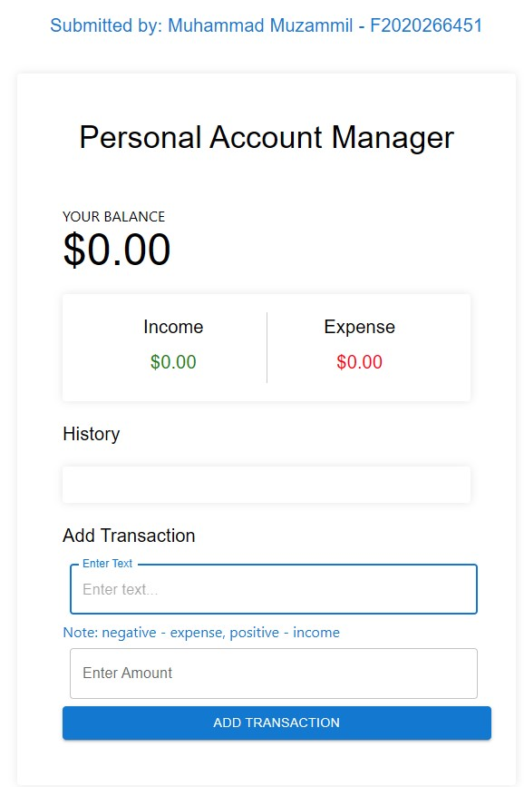**

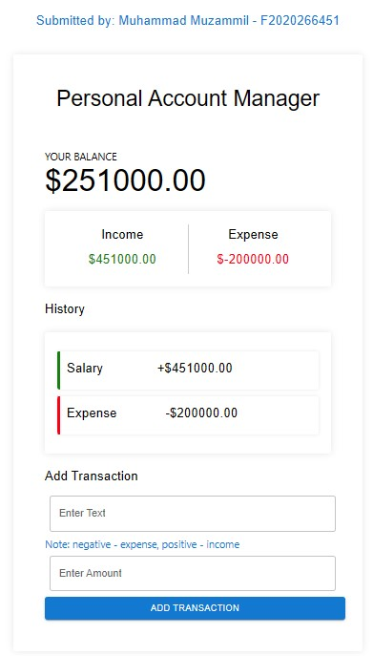

**Code snippet of App.js:   
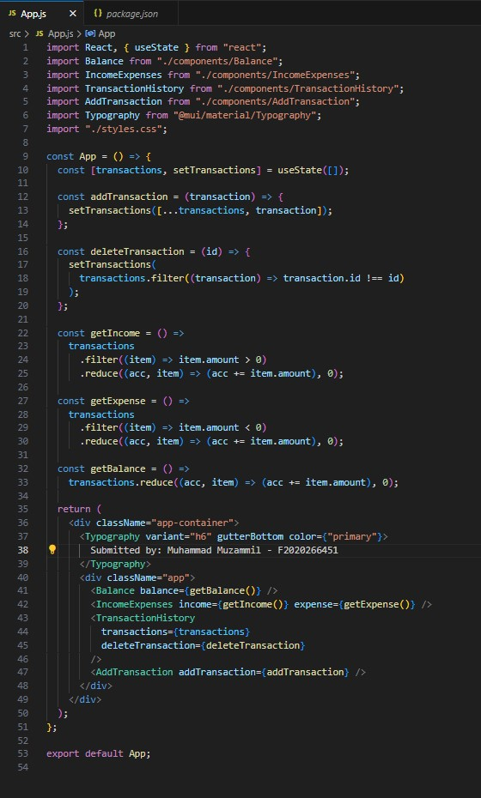**

**Component folder which contains:  
  
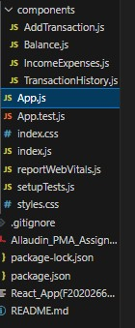**

**Code snippet Balance.js to check balance:**

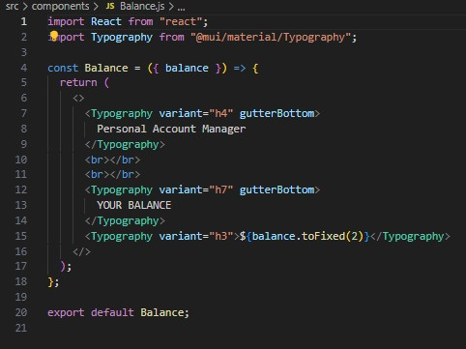

**Also Added a Delete Button on Transaction History which will also change Your Balance in case of deletion.   
  
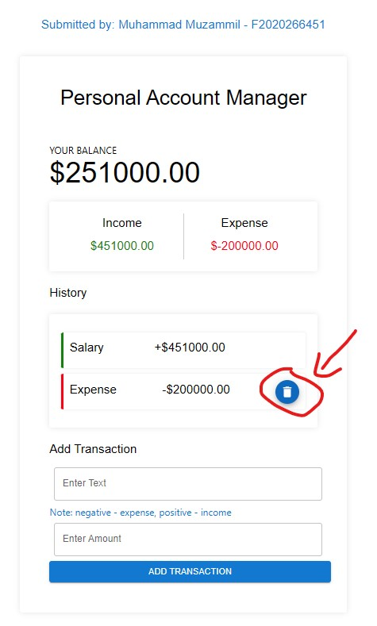**

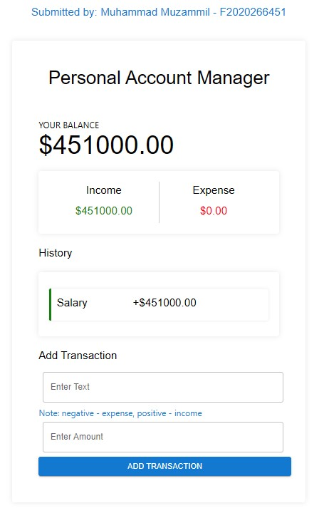

**For UI I used Material UI library of React, which helped me create Buttons, Typography/Fonts.**

**Checks for Empty fields before submitting.**

